CHOPOTWO SOSTIN GRAVITY WATER PROJECT

Sostin Sub-location, Sekerr location, West Pokot County
Chopotwo Primary School : http://maps.google.com/maps?q=01.56466,35.41973

The project was established in November 2012 out of a mutual desire between the Chopotwo Community, Terry John Hummerston (TJH) and The Together We Succeed Foundation (TWS) from Holland to initially provide the isolated Chopotwo Primary School and Community with a direct and reliable supply of clean water. Both TJH and TWS have been active with water and education in Sekerr for 10 years. TJH merely funded an unsuccessful community endeavour to get water to Chopotwo in 2005 and TWS supported classroom constructions in 2011. Petra Munneke of TWS agreed to sponsor the Chopotwo pipeline with TJH controlling work and funds.
With the knowledge that an existing intake had been identified as the water source 5KM away, which was unreliably taking water to the Sostin Community and Primary School by means of an unmanaged and dilapidated 2006 CDF (Constituency Development Fund) pipeline, the need to renovate and re-structure management there was also evident.
Over the past three months the project has evolved to include a direct pipeline to Sostin School with a possible fourth pipeline being taken into consideration.
_______________________________________________________

Validation of the Chopotwo Maintenance and Contribution Scheme (MCS) occurred at Baraza on 14/04/13 with work commencing 2 weeks later. During first few working days local supervisors were identified from the Community workforce and trained in installation methodology by the Project Controller (PC).
Contributions of 50/- per month for each registered household started when construction began, with penalties of 200/- for work time tea being immediately enforced by the Community leaders for non-attendance without reasonable excuse.
Work on the Chopotwo pipeline continues slowly but surely with approximately 3km of the 5km installed. With the locality’s harsh rocky terrain being much the reason for slow progress, the pipelines advancement had also been slowed by just two working days per week and short work days due to the Community having a long walk to site and back in the early stages. But the number of work days increased to 3/week during school holidays.
Implementation of the systematic installation practices has been very effective. Furrows are being dug to required depth with little supervision or prompting. GI metal pipe work has been cemented in place for stability. Installed pipeline is being covered, concealed and planted satisfactorily. ‘Rock paving’ is laid atop the pipeline where it passes through farms for identification purposes and where necessary the route is blocked to prevent new pathways developing along the pipeline. Where rain water run-off may cause erosion in the future ‘Diversion and Diffusion’ work is being performed with the locations being identified as ‘Black spots’ and documented for future inspections.
Not only have physical constructions been executed satisfactorily but the thorough installation procedures appear to have instilled a belief that the pipeline will be strong and long lasting unlike previous Community controlled water projects. It has also been communicated by the Community that the definitive MCS has given them a confidence and enthusiasm for their projects sustainability and the communities’ development.

Involvement with the Sostin Community, existing CDF pipeline and its management Committee has been a challenge as anticipated. Progress in assembling a new Pipeline Management Committee (PMC) and formulating MCS has been very slow but has been achieved, although organising Baraza and obtaining community endorsement of MCS is still absent.
______________
AUGUST 2013
It is common knowledge within the Community that the CDF Committee is prone to misappropriation of resources and has monopolised the management of all community projects for many years. Since formulation of Sostin MCS’s with its mandate of small but compulsory Community contributions and hence management of those funds, CDF Committee members have frustrated progress amid cries of neglect and being ignored when it was clear to all they simply coveted inclusion and control.
The actions of a few individuals with purely personal agendas were obstructing progress against the wishes of the Community.
It had also been expected that succumbing to requests and agreeing to construct a new and direct pipeline to Sostin PS, as well as renovating the existing CDF pipeline, the Community would celebrate fully. But Community/CDF Committee plans in 2006 had identified other areas of Sostin to receive water, and although it was impressed that the Contractor/Donor were not responsible or obliged to continue what CDF had not accomplished, certain parts of the Community insisted any new funding would go into their pipeline before the school had its own direct supply. Again it was explained by Community that just a few individuals with personal agendas were fuelling discontent and obstructing progress.
Poor relations between Chief and Assistant Chief have also not helped matters when strong leadership was required.

Although the local administration is in itself problematic and often ineffective, the Area Chief has acted swiftly and decisively, and hopefully the issue of CDF Committee interference has been resolved and all such impediments eliminated.
The Community were also reminded of previous Contractor/Donor sentiments and their Pre-survey Information and Requirements (PSIR) document which states The Contractor my recommend to the Donor at any time that funding (and/or materials) be withdrawn and re-directed to other projects if it is perceived the Community/PMC is being insincere in their actions and request for sustainable water and effective management.

The amount of water available from the existing CDF source for a third and possibly fourth pipeline was also of concern but observable demonstration and calculations persuaded otherwise.
______________

Entering into operations with the Sostin Community, known for its poor administration, political wrangles and past misappropriation of resources would always be fraught with difficulties. The creation of a new and development minded Pipeline Management Committee (PMC) has been of huge benefit in suppressing the dissenting few. Working with well-respected individuals from within the community has also been very important in negotiations and reducing conflict.
When required the Chief has been influential in stemming problems although this may possibly be due to the DO and Marich OCS being well aware of operations.
______________

Although the disruption to the Sostin CDF committees control over all Community matters and development may have exacerbated some internal conflicts, and possibly created a few more problems, to successfully establish another committee (PMC) that can be seen to put the interests of the Community first, who can manage a project and funds in a successful and transparent manner, would give the Community a new confidence and trust in its representatives which should facilitate greater Community involvement in future development.

Next quarter schedule Completion of physical constructions to Chopotwo pipeline.
Water tank installation. Community and animal watering points constructed at Chopotwo.
Endorsement of Sostin School MCS by the community.
Full commencement of Sostin School direct pipeline.
Review and endorsement of CDF pipeline MCS. AUGUST 2013

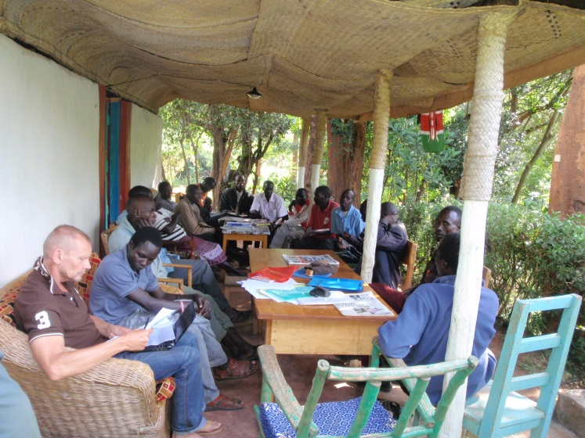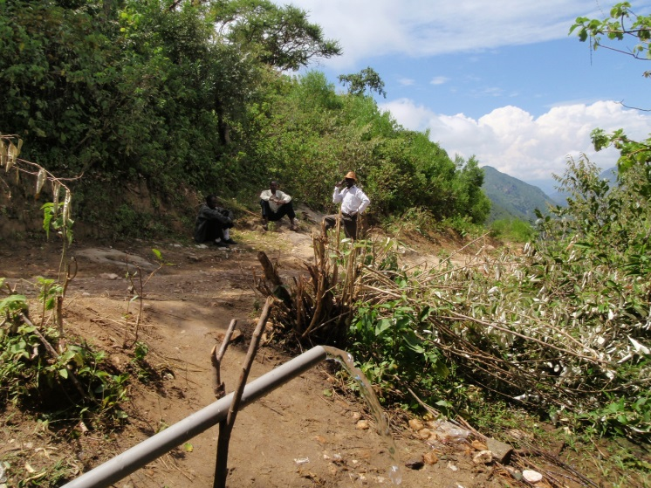
Committee planning meetings and MCS formulation Water gets a glimpse of Yas Hill (Chopotwo)

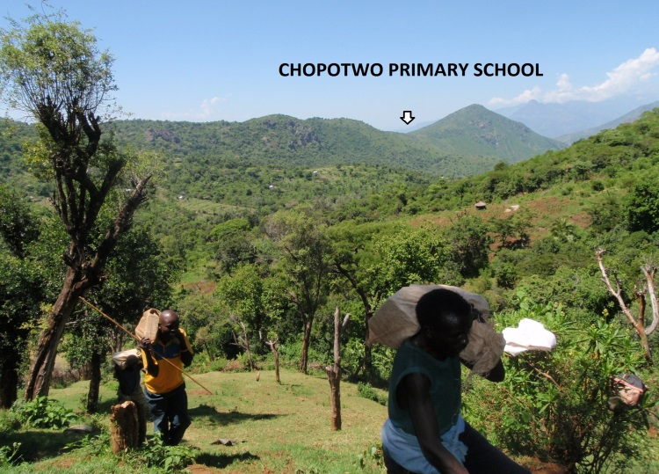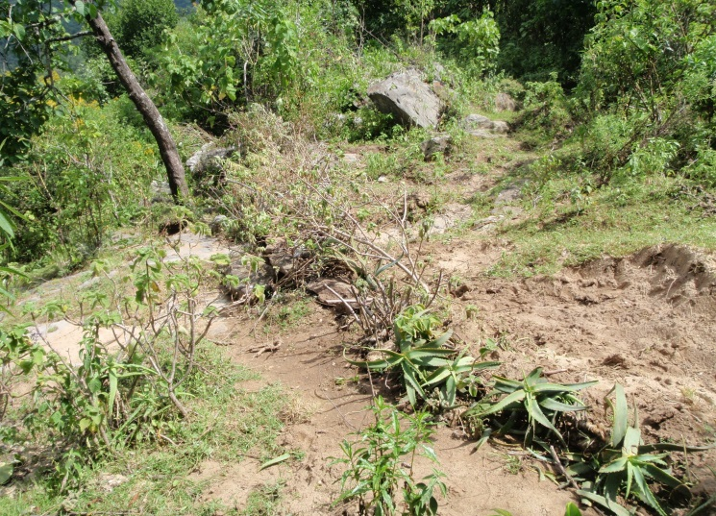
Community transports materials to intake for Junction Thorough concealment and planting along installed
box construction. May 2013 pipeline

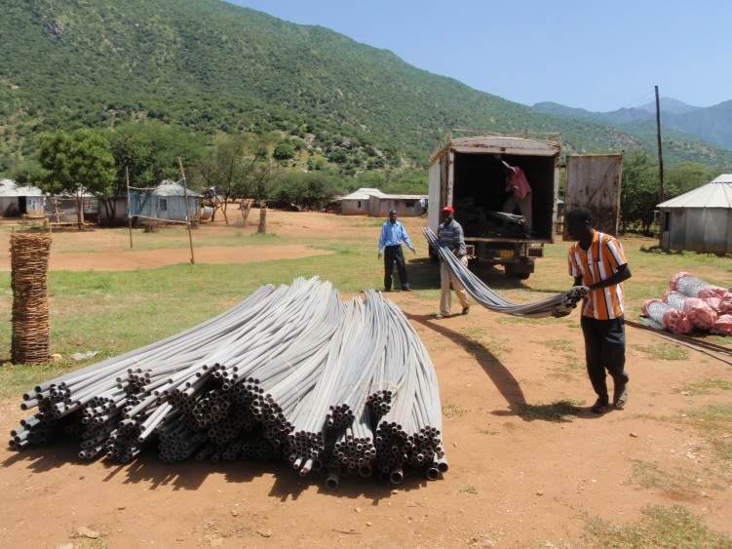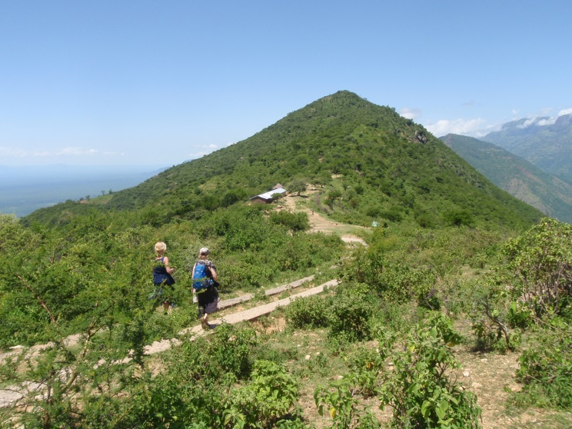

Materials arrive at Marich Police Post, still to be Petra Munneke and Margriet Jeninga of Together We
transported to Sekerr (Top right distant mountains) Succeed Foundation approach Chopotwo. May 2013

AUGUST 2013

